PROGRAM 1:-

SWAPPING OF 2 NUMBERS USING POINTERS-

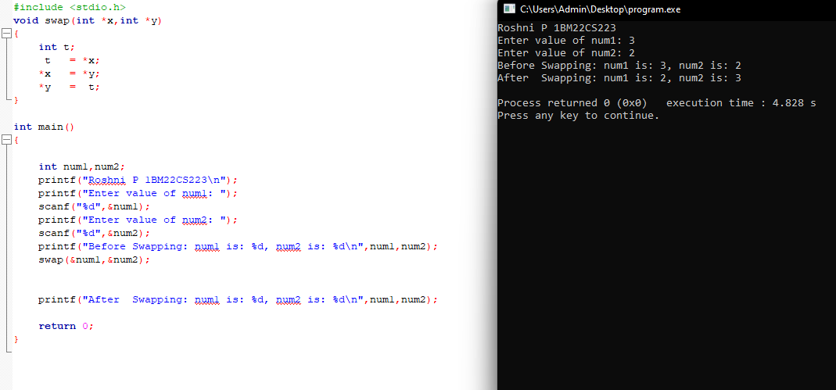

PROGRAM 2:-

DYNAMIC MEMORY ALLOCATION(MALLOC,FREE,CALLOC,REALLOC)

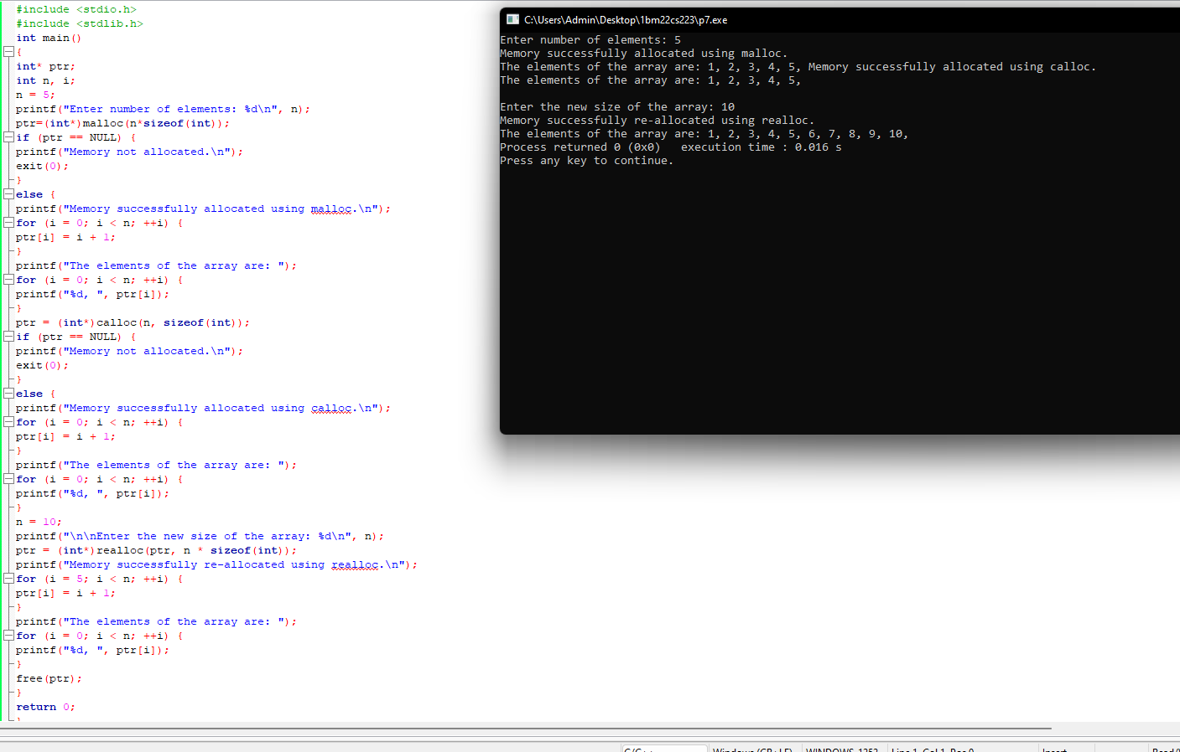

PROGRAM 3:-

Stack Implementation -

